**Bachelor of Computer and Information Sciences**

**Contemporary Issues in Software Engineering**

**Semester 2, 2024**

**ASSIGNMENT 1A: Worksheet 4 (30% of Ass1A)**

*Next.js Project*

# Deliverables and Due dates:

You are required to complete the Worksheet and keep evidence as you do it by taking screenshots of your work, as well as explanations.

**This worksheet should be Checked off and uploaded to Canvas by end of Tutorial Week 5.**

**Introduction**

This worksheet introduces you to Next.js, routing URLS & different page components.

You will also get practice in making a drop-down input, an input form, and a display table.

Everything will be done from the frontend React, with some dummy data files in the frontend.

For the SPEED product development, you should be able to create a server backend with nest.js/node.js, connect this backend to MongoDB Atlas, and connect the React front end to the backend.

**Overview**

This is just an overview – the actual instructions are later

1. Setup create-next-app frontend (Using Next.js)
2. Setup Git and GitHub
3. Create some simple pages
4. Create some dummy data
5. Change the SE-Practices display page component to use a dropdown component and table component
6. Change the Submit-Article page component to use a form component
7. Deploy with Vercel
8. Open VSCode and Open the CISE_REPOS folder
9. Create folder “worksheet4” under the CISE_REPOS folder
10. In VS Code create folder “backend” under “worksheet4” folder
11. Open a new terminal (CLI) in folder in “worksheet4” folder
12. In this folder:

> npx create-next-app@latest frontend

*(This assumes you have node.js installed on your machine from previous worksheets)*

NOTE: We used [App Router](https://nextjs.org/docs/app/building-your-application/routing) in worksheet 3 (the one recommended by NextJS), and in worksheet 4 we want to show you the other one: the [Pages Router](https://nextjs.org/docs/pages/building-your-application/routing). You can still use the app router, but you will need to adapt the file/folder/code accordingly. You are free to use any one in assignment B.

You can test using the command – if this runs you are on the right track (cd into the right folder first!):

> npm run dev

1. Install extra dependencies. Some dependencies we used in this worksheet may be missing in the new project, so we need to install them manually, for example, SASS (for .scss style files).

Or, next-auth:

You can use the command “npm install xxx” to install the missing “xxx” package.

Here are the missing packages we identified: sass next-auth react-icons react-hook-form

Use the command to install them: npm install sass next-auth react-icons react-hook-form

1. Clean up our project to start from a clean slate. Simply remove everything in your “src” folder. Then create four folders as shown:

1. **Create some pages**

In the “pages” folder, create these files:

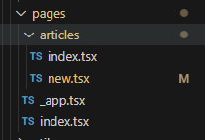

**Copy the following code into their respective locations:**

***pages/index.tsx:***

export default function Home() {

  return (

    <div className="container">

      <h1>Software Practice Empirical Evidence Database (SPEED)</h1>

    </div>

  );

}

***pages/_app.tsx:***

import "../styles/globals.scss";

import type { AppProps } from "next/app";

import { SessionProvider } from "next-auth/react";

import PopulatedNavBar from "../components/PopulatedNavBar";

function MyApp({ Component, pageProps: { session, ...pageProps } }: AppProps) {

  return (

    <SessionProvider session={session}>

      <PopulatedNavBar />

      <Component {...pageProps} />

    </SessionProvider>

  );

}

export default MyApp;

***pages/articles/index.tsx***

import { GetStaticProps, NextPage } from "next";

import SortableTable from "../../components/table/SortableTable";

import data from "../../utils/dummydata";

interface ArticlesInterface {

  id: string;

  title: string;

  authors: string;

  source: string;

  pubyear: string;

  doi: string;

  claim: string;

  evidence: string;

}

type ArticlesProps = {

  articles: ArticlesInterface[];

};

const Articles: NextPage<ArticlesProps> = ({ articles }) => {

  const headers: { key: keyof ArticlesInterface; label: string }[] = [

    { key: "title", label: "Title" },

    { key: "authors", label: "Authors" },

    { key: "source", label: "Source" },

    { key: "pubyear", label: "Publication Year" },

    { key: "doi", label: "DOI" },

    { key: "claim", label: "Claim" },

    { key: "evidence", label: "Evidence" },

  ];

  return (

    <div className="container">

      <h1>Articles Index Page</h1>

      <p>Page containing a table of articles:</p>

      <SortableTable headers={headers} data={articles} />

    </div>

  );

};

export const getStaticProps: GetStaticProps<ArticlesProps> = async (_) => {

  // Map the data to ensure all articles have consistent property names

  const articles = data.map((article) => ({

    id: article.id ?? article._id,

    title: article.title,

    authors: article.authors,

    source: article.source,

    pubyear: article.pubyear,

    doi: article.doi,

    claim: article.claim,

    evidence: article.evidence,

  }));

  return {

    props: {

      articles,

    },

  };

};

export default Articles;

**pages/articles/new.tsx**

import { FormEvent, useState } from "react";

import formStyles from "../../styles/Form.module.scss";

const NewDiscussion = () => {

  const [title, setTitle] = useState("");

  const [authors, setAuthors] = useState<string[]>([]);

  const [source, setSource] = useState("");

  const [pubYear, setPubYear] = useState<number>(0);

  const [doi, setDoi] = useState("");

  const [summary, setSummary] = useState("");

  const [linkedDiscussion, setLinkedDiscussion] = useState("");

  const submitNewArticle = async (event: FormEvent<HTMLFormElement>) => {

    event.preventDefault();

    console.log(

      JSON.stringify({

        title,

        authors,

        source,

        publication_year: pubYear,

        doi,

        summary,

        linked_discussion: linkedDiscussion,

      })

    );

  };

  // Some helper methods for the authors array

  const addAuthor = () => {

    setAuthors(authors.concat([""]));

  };

  const removeAuthor = (index: number) => {

    setAuthors(authors.filter((_, i) => i !== index));

  };

  const changeAuthor = (index: number, value: string) => {

    setAuthors(

      authors.map((oldValue, i) => {

        return index === i ? value : oldValue;

      })

    );

  };

  // Return the full form

  return (

    <div className="container">

      <h1>New Article</h1>

      <form className={formStyles.form} onSubmit={submitNewArticle}>

        <label htmlFor="title">Title:</label>

        <input

          className={formStyles.formItem}

          type="text"

          name="title"

          id="title"

          value={title}

          onChange={(event) => {

            setTitle(event.target.value);

          }}

        />

        <label htmlFor="author">Authors:</label>

        {authors.map((author, index) => {

          return (

            <div key={`author ${index}`} className={formStyles.arrayItem}>

              <input

                type="text"

                name="author"

                value={author}

                onChange={(event) => changeAuthor(index, event.target.value)}

                className={formStyles.formItem}

              />

              <button

                onClick={() => removeAuthor(index)}

                className={formStyles.buttonItem}

                style={{ marginLeft: "3rem" }}

                type="button"

              >

                -

              </button>

            </div>

          );

        })}

        <button

          onClick={() => addAuthor()}

          className={formStyles.buttonItem}

          style={{ marginLeft: "auto" }}

          type="button"

        >

          +

        </button>

        <label htmlFor="source">Source:</label>

        <input

          className={formStyles.formItem}

          type="text"

          name="source"

          id="source"

          value={source}

          onChange={(event) => {

            setSource(event.target.value);

          }}

        />

        <label htmlFor="pubYear">Publication Year:</label>

        <input

          className={formStyles.formItem}

          type="number"

          name="pubYear"

          id="pubYear"

          value={pubYear}

          onChange={(event) => {

            const val = event.target.value;

            if (val === "") {

              setPubYear(0);

            } else {

              setPubYear(parseInt(val));

            }

          }}

        />

        <label htmlFor="doi">DOI:</label>

        <input

          className={formStyles.formItem}

          type="text"

          name="doi"

          id="doi"

          value={doi}

          onChange={(event) => {

            setDoi(event.target.value);

          }}

        />

        <label htmlFor="summary">Summary:</label>

        <textarea

          className={formStyles.formTextArea}

          name="summary"

          value={summary}

          onChange={(event) => setSummary(event.target.value)}

        />

        <button className={formStyles.formItem} type="submit">

          Submit

        </button>

      </form>

    </div>

  );

};

export default NewDiscussion;

8b) Now create the following files similar to how we created the pages: (Note if you haven’t already please create the **components** folder first)

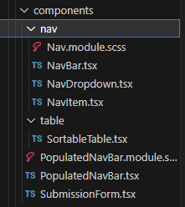

**Create these files in the nav folder:**

**components/nav/NavBar.tsx**

import React from "react";

import styles from "./Nav.module.scss";

type Props = {

  children: React.ReactNode;

};

const NavBar = ({ children }: Props) => {

  return <nav className={styles.navbar}>{children}</nav>;

};

export default NavBar;

**components/nav/NavDropdown.tsx**

import React from "react";

import styles from "./Nav.module.scss";

type Props = {

  children?: React.ReactNode;

};

const NavDropdown = ({ children }: Props) => {

  return <div className={styles.dropdown_container}>{children}</div>;

};

export default NavDropdown;

**components/nav/NavItem.tsx**

import { useRouter } from "next/router";

import React from "react";

import styles from "./Nav.module.scss";

type Props = {

  route?: string;

  children: React.ReactNode;

  end?: boolean;

  dropdown?: boolean;

  onClick?: boolean | (() => void);

  style?: React.CSSProperties;

};

const NavItem = ({ children, route, end, dropdown, onClick, style }: Props) => {

  const router = useRouter();

  const navigate: React.MouseEventHandler<HTMLDivElement> = (event) => {

    if (typeof route === "string") {

      router.push(route);

    }

    event.stopPropagation();

  };

  return (

    <div

      style={style}

      className={`${route || onClick ? styles.clickable : styles.navitem}${

        end ? ` ${styles.end}` : ""

      }${dropdown ? ` ${styles.dropdown}` : ""}`}

      onClick={typeof onClick === "function" ? onClick : navigate}

    >

      {children}

    </div>

  );

};

export default NavItem;

**components/nav/Nav.module.scss**

.navbar {

  display: flex;

  position: relative;

  top: 0;

  flex-direction: row;

  width: 100%;

  background-color: darkblue;

  align-items: center;

  color: aliceblue;

  font-size: 1.5em;

  font-weight: bold;

  transition: top 0.5s;

  height: fit-content;

}

.hide {

  top: -3em;

}

.navitem {

  position: relative;

  padding: 1em;

  width: auto;

  display: flex;

  flex-direction: row;

  align-items: center;

  cursor: default;

  white-space: nowrap;

}

.clickable {

  @extend .navitem;

  cursor: pointer;

}

.clickable:hover {

  backdrop-filter: brightness(50%);

}

.dropdown_container {

  visibility: hidden;

  display: flex;

  flex-direction: column;

  background-color: darkblue;

  position: absolute;

  top: 100%;

  right: 0;

}

.dropdown:hover {

  cursor: pointer;

  backdrop-filter: brightness(50%);

  .dropdown_container {

    visibility: visible;

  }

}

.end {

  margin-left: auto;

}

**Create these files in the table folder**

**components/table/SortableTable.tsx**

import React from "react";

interface SortableTableProps {

  headers: { key: string; label: string }[];

  data: any[];

}

const SortableTable: React.FC<SortableTableProps> = ({ headers, data }) => (

  <table>

    <thead>

      <tr>

        {headers.map((header) => (

          <th key={header.key}>{header.label}</th>

        ))}

      </tr>

    </thead>

    <tbody>

      {data.map((row, i) => (

        <tr key={i}>

          {headers.map((header) => (

            <td key={header.key}>{row[header.key]}</td>

          ))}

        </tr>

      ))}

    </tbody>

  </table>

);

export default SortableTable;

**Create these files in the components folder**

**components/PopulatedNavBar.module.scss**

.user_container {

  position: absolute;

  aspect-ratio: 1;

  backdrop-filter: brightness(50%);

  display: flex;

  align-items: center;

  justify-content: center;

  width: 2em;

  border-radius: 100%;

  left: 1em

}

**components/PopulatedNavBar.tsx**

import { IoMdArrowDropdown } from "react-icons/io";

import NavBar from "./nav/NavBar";

import NavDropdown from "./nav/NavDropdown";

import NavItem from "./nav/NavItem";

const PopulatedNavBar = () => {

  return (

    <NavBar>

      <NavItem>SPEED</NavItem>

      <NavItem route="/" end>

        Home

      </NavItem>

      <NavItem dropdown route="/articles">

        Articles <IoMdArrowDropdown />

        <NavDropdown>

          <NavItem route="/articles">View articles</NavItem>

          <NavItem route="/articles/new">Submit new</NavItem>

        </NavDropdown>

      </NavItem>

    </NavBar>

  );

};

export default PopulatedNavBar;

**components/SubmissionForm.tsx**

import React from "react";

import { useForm } from "react-hook-form";

export default function SubmissionForm() {

  const { register, handleSubmit } = useForm();

  const onSubmit = (data: any) => JSON.stringify(data);

  return (

    <form onSubmit={handleSubmit(onSubmit)}>

      <input {...register("title")} placeholder="Title" />

      <p>

        <input {...register("authors")} placeholder="Authors" />

      </p>

      <p>

        <input {...register("source")} placeholder="Source" />

      </p>

      <p>

        <input {...register("pubyear")} placeholder="Publication Year" />

      </p>

      <p>

        <input {...register("doi")} placeholder="DOI" />

      </p>

      <select {...register("linked_discussion")}>

        <option value="">Select SE practice...</option>

        <option value="TDD">TDD</option>

        <option value="Mob Programming">Mob Programmin</option>

      </select>

      <input type="submit" />

    </form>

  );

}

**Create these files in the src/utils folder**

**utils/table_functions.ts**

/**

 * Function to sort data based on a sortKey, and whether the sorting should be reversed or not.

 *

 * @param tableData The data to sort. This is an array of objects

 * @param sortKey The key to sort by.

 * @param reverse True if we should reverse the order of sorting (sorts ascending if false, descending if true)

 * @returns

 */

export function sortData<T>(

  tableData: T[],

  sortKey: keyof T,

  reverse: boolean

): T[] {

  const sortedData = tableData.sort((a, b) => {

    return a[sortKey] > b[sortKey] ? 1 : -1;

  });

  if (reverse) {

    return sortedData.reverse();

  }

  return sortedData;

}

**Create these files in the src/styles folder**

**styles/Form.module.scss**

.form {

  display: flex;

  flex-direction: column;

  max-width: 30em;

}

.formItem {

  padding: 1em;

  margin: 1em 0;

  flex-grow: 1;

}

.formTextArea {

  @extend .formItem;

  min-height: 8em;

}

.arrayItem {

  display: flex;

  flex-direction: row;

  align-items: center;

  justify-content: stretch;

}

.buttonItem {

  width: 3rem;

  height: 3rem;

  flex-grow: 0;

  font-size: 1.5em;

}

**styles/globals.scss**

.form {

  display: flex;

  flex-direction: column;

  max-width: 30em;

}

.formItem {

  padding: 1em;

  margin: 1em 0;

  flex-grow: 1;

}

.formTextArea {

  @extend .formItem;

  min-height: 8em;

}

.arrayItem {

  display: flex;

  flex-direction: row;

  align-items: center;

  justify-content: stretch;

}

.buttonItem {

  width: 3rem;

  height: 3rem;

  flex-grow: 0;

  font-size: 1.5em;

}

**…AND BREATHE YOU DID IT; YOU SUCCESSFULLY COPIED AND PASTED ALL THIS CODE… A RITE OF PASSAGE FOR EVERY DEVELOPER.** [**https://medium.com/@alejandro_duarte/copy-paste-based-development-1fc9070fb00f**](https://medium.com/@alejandro_duarte/copy-paste-based-development-1fc9070fb00f)

As funny as that is, you won’t learn anything and take away skills in the workforce you need without that desire to understand what you just copied. Here are a couple of resources I strongly suggest you read in your spare time; a great developer loves to struggle that’s when we learn best!

* **Learn more about scss here:**

<https://www.geeksforgeeks.org/what-is-the-difference-between-css-and-scss/>

* **React useState:**

<https://react.dev/reference/react/useState>

* **Next.js App Router:**

<https://react.dev/learn/start-a-new-react-project#nextjs-app-router>

(*If it is not working ask a TA as they have access to a REPO that will be able to guide you further if you are struggling. Use this as a last resort remember… to struggle is to learn! Try debug what is wrong yourself.*)

**Note:**

This adds the <Router> tags around the outside <div> tags (it’s actually using the BrowserRouter component). The BrowserRouter component provides the foundation for the navigation and browser history handling, that routing is made up of.

Next we define our navigation links. We already have list elements with each element defined. We will replace them with the more specialized NavLink component. These are between the **<ul className="header">** tags. We will turn this into a menu bar later using some css.

For each link, pay attention to the URL we are telling our router to navigate to. This URL value (defined by the ***to*** prop) acts as an identifier to ensure the right content gets loaded.

The way we match the URL with the content is by using a Route component – between the **<div classname=”content”>** tags.

The format for the Route component is:

**<Route path = “***the URL in the browser***”component = {***the name of the component to render***}/>**

1. You should see & have the following file structure (**Create a file named dummydata.json that is empty for now**) for each of your pages (and links)

**Double check this – are you missing any files? (Create a file named dummydata.ts that is empty for now)**

1. Now set up dummy article data to use on our front end

In the **src** folder create a file inside **utils** called **dummydata.ts** and copy this code into it.

const data = [

{

id: "1",

title: 'An experimental evaluation of test driven development vs. test-last development with industry professionals',

authors: "Munir, H., Wnuk, K., Petersen, K., Moayyed, M.",

source: "EASE",

pubyear: "2014",

doi: "https://doi.org/10.1145/2601248.2601267",

claim: "code quality improvement",

evidence: "strong support",

},

{

_id: "2",

title: 'An experimental evaluation of test driven development vs. test-last development with industry professionals',

authors: "Munir, H., Wnuk, K., Petersen, K., Moayyed, M.",

source: "EASE",

pubyear: "2014",

doi: "https://doi.org/10.1145/2601248.2601267",

claim: "product quality improvement",

evidence: "weak support",

},

{

_id: "3",

title: 'Realizing quality improvement through test driven development: results and experiences of four industrial teams',

authors: "Nagappan, N., Maximilien, E. M., Bhat, T., Williams, L.",

source: " Empirical Software Engineering, 13(3), 289–302",

pubyear: "2008",

doi: "https://doi.org/10.1007/s10664-008-9062-z",

claim: "product quality improvement",

evidence: "weak support",

},

{

_id: "4",

title: "Does Test-Driven Development Really Improve Software Design Quality?",

authors: "Janzen, D. S.",

source: "Software, IEEE, 25(2) 77-84",

pubyear: "2008",

doi: "",

claim: "code quality improvement",

evidence: "strong support",

},

{

_id: "5",

title: "A Comparative Case Study on the Impact of Test-Driven Development on Program Design and Test Coverage",

authors: "Siniaalto, M., Abrahamsson, P.",

source: "ArXiv.Org, cs.SE, arXiv:1711.05082-284",

pubyear: "2017",

doi: "https://doi.org/10.1109/esem.2007.35",

claim: "code quality improvement",

evidence: "weak against",

},

];

export default data;

[ NOTE YOUR APPLICATION SHOULD BE RUNNING AT THIS POINT WITH

npm run dev IF YOU ARE GETTING ERRORS PLEASE ASK FOR ASSISTANCE OR GO BACK THROUGH THE CODE ]

1. Your browser should show the following for localhost:3000/articles

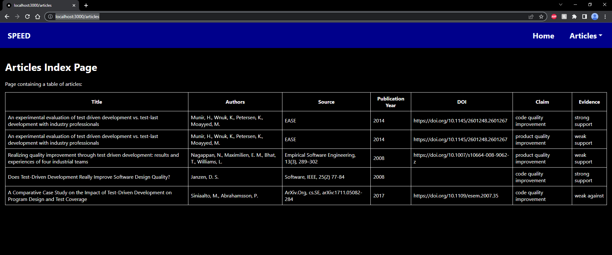

Also the data for the Dropdown list in SPEED and the table in SPEED should all come from a MongoDB using **axios** to communicate with Nest.js APIs which use mongoose to communicate with MongoDB Atlas. Also for you to work out (look at Worksheet 2 & 3)

The table could have been created with a number of other libraries. Here is a good summary and some code examples.

<https://blog.bitsrc.io/top-5-react-table-libraries-170505f75da7>

Your browser should show the following for localhost:3000/articles/new

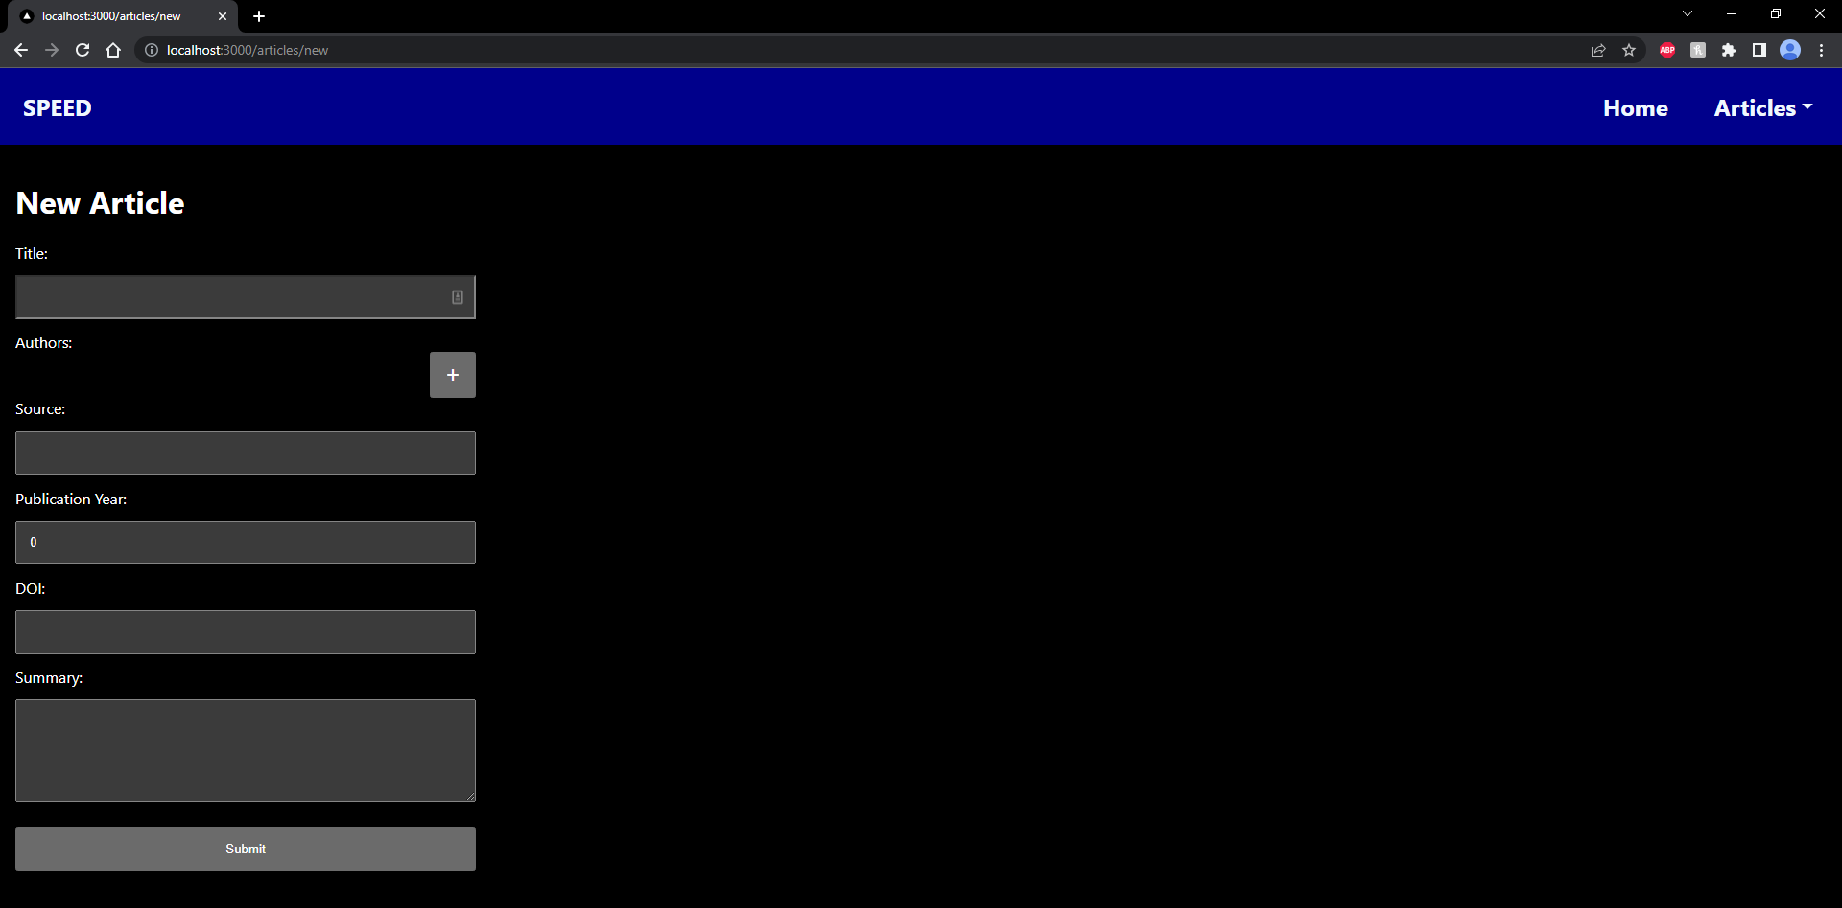

**Handling Error 404 – no such page error**

For a website or a simple multi-page app, a 404 “page not found” is one of the obvious things to handle and know how to use if you decide to work with react-router. We set that up let’s take a look at it:

1. Try entering **localhost:3000/blabla** – you should be redirected to your 404 page (remember to start your application first: npm run dev, OR, npm run build THAN npm run start)

**Notes for extending this to use in SPEED app.**

If you enter some data and press “Submit” it will display the json in the console log which will be returned. In SPEED, this would then be sent to the backend and update the data in the MongoDB database. This is for you to work out for SPEED.

You can use the data in the [TDD_Test_Data-3.docx](https://canvas.aut.ac.nz/courses/13657/files/3542063?wrap=1) file on Canvas to create some test data in MongoDB Atlas. (see worksheets 2 & 3 for MongoDB Atlas setup)

The frontend and server for SPEED would then be served to us using Vercel (see worksheet 3 for hints)

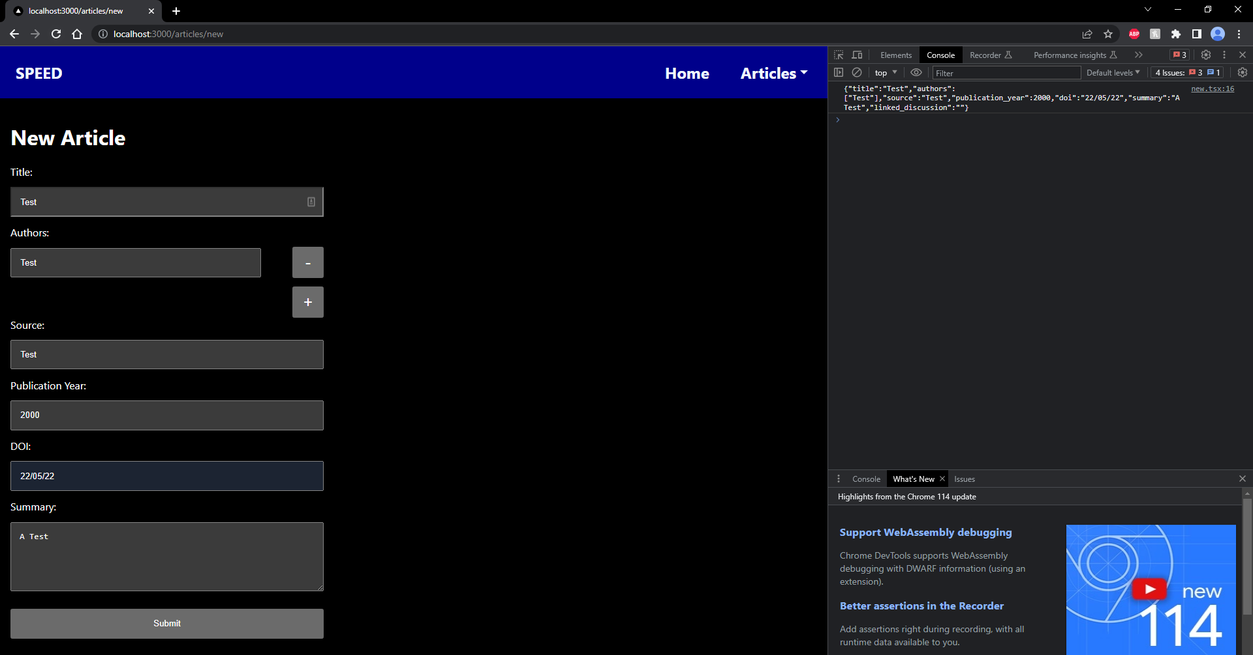

**Name: Date:**

**Worksheet Evidence:**

This worksheet requires some answers to questions and **at least three selectively captured screenshots with an in depth reflection** as evidence. The aim is to be able to learn from the exercise, and evidence that.

**For each of your three selected screenshots (or sequence of shots) in a brief paragraph or two reflect on:**

* Why you have selected it?
* What have you learnt in this part of the worksheet?
* What was new or surprising?
* What useful external resource(s) did you consult and why? Provide a link(s) to the resource.

Evidence to Be uploaded to Canvas as well as Checked off by the Tutor (By end of Week 5)

|  |  |
| --- | --- |
| **Evidence** | **Check** |

|  |  |
| --- | --- |
| 1. You could explain the structure of the worksheet activity. You could paste a screenshot of your folders and files (Do you have the correct file structure set up?) |  |
| 1. You could discuss the branches you have created and how they have been used. A screenshot of your GitHub dashboard to show the branches, commits to support your answer may be suitable. |  |
| 1. You could discuss how the articles are created, and provide a screenshot of the final localhost:3000/articles/new page with some data in the form and submitted. |  |
| 1. You could discuss how the articles are stored, and perhaps provide a screenshot of the final localhost:3000/articles page with the table. |  |
| 1. How would you keep track of the status of a submitted article – whether it passed moderation or not, has been analysed and entered into the database or not. |  |
| 1. List three user stories for the Moderator |  |
| 1. Sketch a Design of the page that will address those user stories and take a photo and paste it here–   *Note: – For example, the moderator page could display a selectable list of articles to be moderated and a form to check if the selected article is (a) Not a duplicate already in SPEED (b) is relevant -i.e. about empirical evidence of a claimed benefit for SE practice (c) is from a reputable source (peer reviewed). If it passes all three criteria, it is put into the Analyst’s list.* |  |
| 1. [Optional] If you want to go further you could discuss how the Vercel deployment workflow is set up, and perhaps provide a screenshot of the SPEED app hosted on Vercel. (See the appendix below). |  |

**Appendix**

**Deploy your app to Vercel and integrate with GitHub Actions for CI/CD**

**Deploy to Vercel via Vercel CLI**

1. Install Vercel CLI if you haven’t.

npm i -g vercel

1. Create a “vercel.json” config file in your app’s root folder.

You can config your Vercel deployment in this config file. For example, this one is a NextJS app, and Vercel has built-in support for it. So in the config file, we put this:

{

    "framework": "nextjs"

}

So that Vercel knows this is a NextJS project, and you do not need to config things such as build command (you can if you want to customize it).

If it is something that Vercel does not have built-in framework support, such as NestJS, you will need to config it manually, like this (for NestJS):

{

    "version": 2,

    "builds": [

      {

        "src": "dist/main.js",

        "use": "@vercel/node"

      }

    ],

    "routes": [

      {

        "src": "/(.*)",

        "dest": "dist/main.js"

      }

    ]

}

1. In your app’s root folder, run terminal command “vercel”, and follow the instructions to login to your Vercel account and setup your Vercel project. After that your app will be built and deployed to Vercel.

An example output of the “vercel” command. Your options might be different, so do not follow my choice:

**Integrate with GitHub Actions**

1. In your project’s root folder (the one “.git” sits in. In my case, it is the “my-next-app” folder) create a “.github” folder, then create a “workflows” folder inside .github folder.

1. Now we create three .yml files for test, preview deployment and production deployment. You can change the file’s name.

test.yml

name: GitHub Actions Test

on:

  push:

    branches: [ "main", "develop" ]

  pull_request:

    branches: [ "main", "develop" ]

  workflow_call:

  workflow_dispatch:

jobs:

  test:

    runs-on: ubuntu-latest

    steps:

      - uses: actions/checkout@v4

      - name: Install dependecies

        run: npm install

      - name: Run test

        run: npm run test:ci

preview.yml

(change the jcchenaut/my-next-app/ to your GitHub account and repo)

name: GitHub Actions Vercel Preview

env:

  VERCEL_ORG_ID: ${{ secrets.VERCEL_ORG_ID }}

  VERCEL_PROJECT_ID: ${{ secrets.VERCEL_PROJECT_ID }}

on:

  workflow_dispatch:

jobs:

  Test:

    uses: jcchenaut/my-next-app/.github/workflows/test.yml@develop

  Deploy-Preview:

    runs-on: ubuntu-latest

    needs: [test]

    steps:

      - uses: actions/checkout@v3

      - name: Install Vercel CLI

        run: npm install --global vercel@canary

      - name: Pull Vercel Environment Information

        run: vercel pull --yes --environment=preview --token=${{ secrets.VERCEL_TOKEN }}

      - name: Build Project Artifacts

        run: vercel build --token=${{ secrets.VERCEL_TOKEN }}

      - name: Deploy Project Artifacts to Vercel

        run: vercel deploy --prebuilt --token=${{ secrets.VERCEL_TOKEN }}

deploy.yml

(change the jcchenaut/my-next-app/ to your GitHub account and repo)

name: GitHub Actions Vercel Deploy

env:

  VERCEL_ORG_ID: ${{ secrets.VERCEL_ORG_ID }}

  VERCEL_PROJECT_ID: ${{ secrets.VERCEL_PROJECT_ID }}

on:

  pull_request:

    branches: [ "main" ]

    types:

      - closed

jobs:

  Test:

    if: github.event.pull_request.merged == true

    uses: jcchenaut/my-next-app/.github/workflows/test.yml@develop

  Deploy-Production:

    if: github.event.pull_request.merged == true

    runs-on: ubuntu-latest

    needs: [Test]

    steps:

      - uses: actions/checkout@v3

      - name: Install Vercel CLI

        run: npm install --global vercel@canary

      - name: Pull Vercel Environment Information

        run: vercel pull --yes --environment=production --token=${{ secrets.VERCEL_TOKEN }}

      - name: Build Project Artifacts

        run: vercel build --prod --token=${{ secrets.VERCEL_TOKEN }}

      - name: Deploy Project Artifacts to Vercel

        run: vercel deploy --prebuilt --prod --token=${{ secrets.VERCEL_TOKEN }}

In my workflow, the “test.yml” will be triggered when a push or a pull request has been created to whether main or develop branch. The “preview.yml” can only be executed manually, since I do not want to make a preview deployment every time that I make some changes to the develop branch. The “deploy.yml” will be triggered only when the pull request to the main branch has been accepted, and new codes has been merged into the main branch. You can config these in your own way by modifying the .yml files.

1. In your GitHub repo’s Settings page, add secrets:

You can find your VERCEL_ORG_ID and VERCEL_PROJECT_ID in your app’s root folder, /.vercel/project.json:

This folder will be created after running the “vercel” command in the previous step.

The VERCEL_TOKEN can be created in your Vercel’s Account Settings:

1. To further protect our main branch from unwanted changes, we can add branch protection rules. Go to the Settings in your GitHub repo:

Click “Add rule”, then you can config the protection rules:

Save the changes when it is done.

1. Now, we can only change the main branch via pull request, and if the test fails, the merge won’t be allowed (your repository must be public or enterprise to enable force protection):

And if the changes have been approved and merged, our production deployment workflow will be triggered, and the app will be deployed to Vercel’s production environment:

